# Report on

**Gifford's voting scheme**

**DS Assignment 8**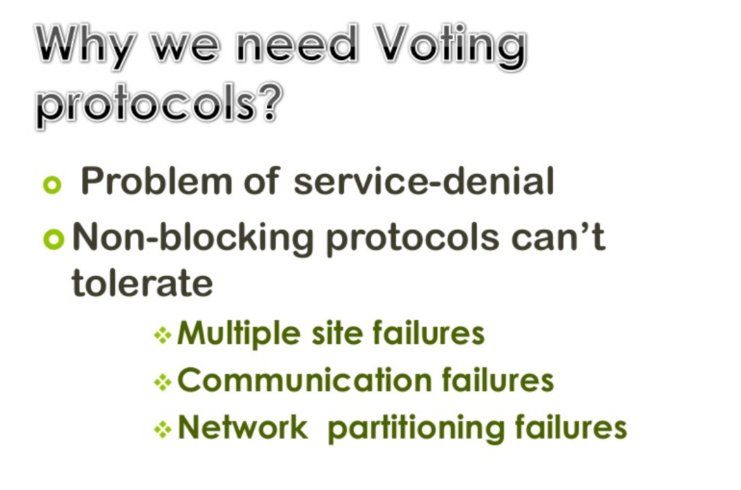

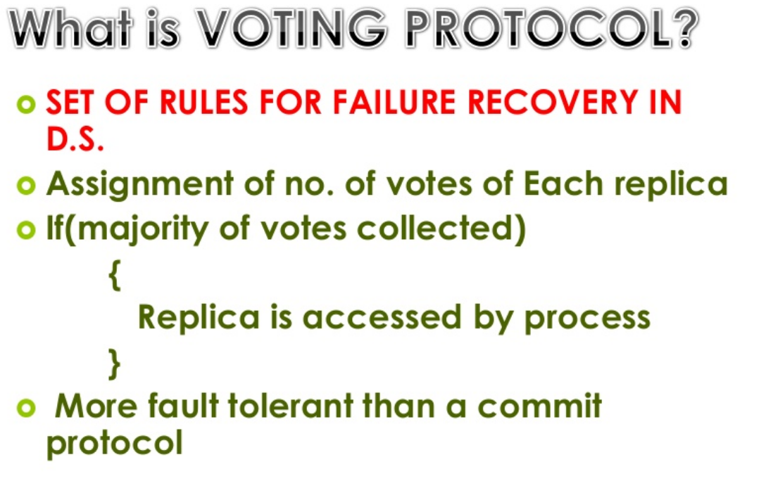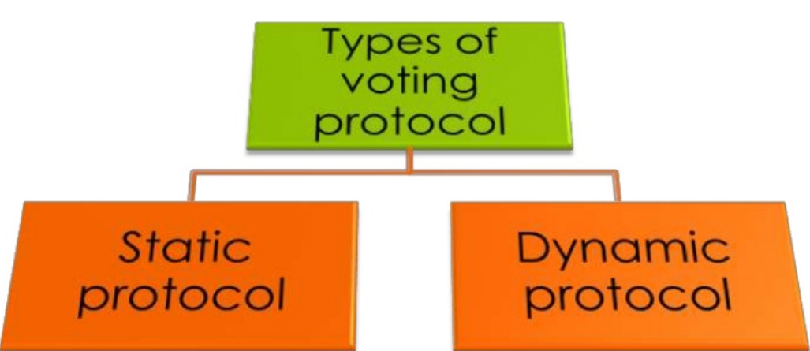

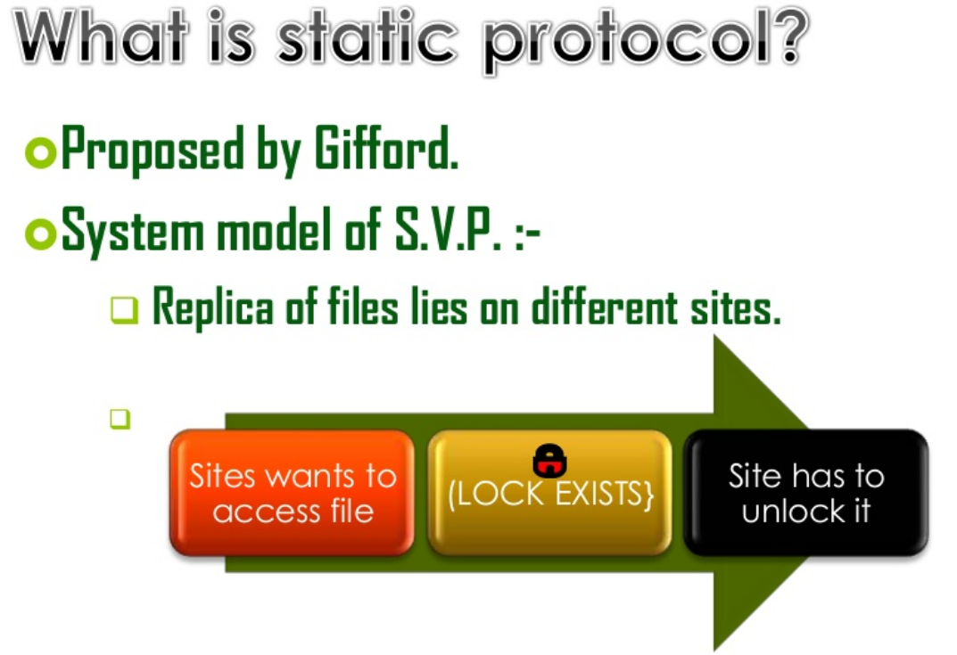

**System Model for Static Voting Protocol**

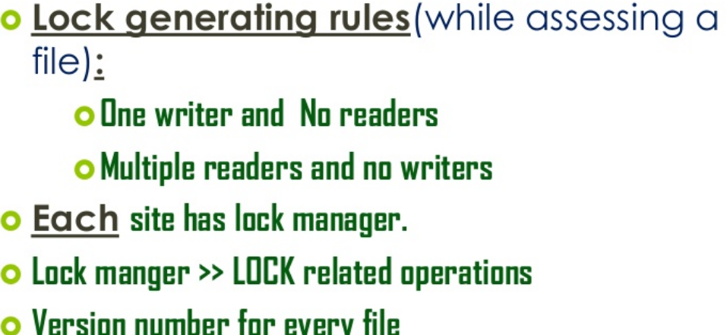

**System Model for Static Voting Protocol**

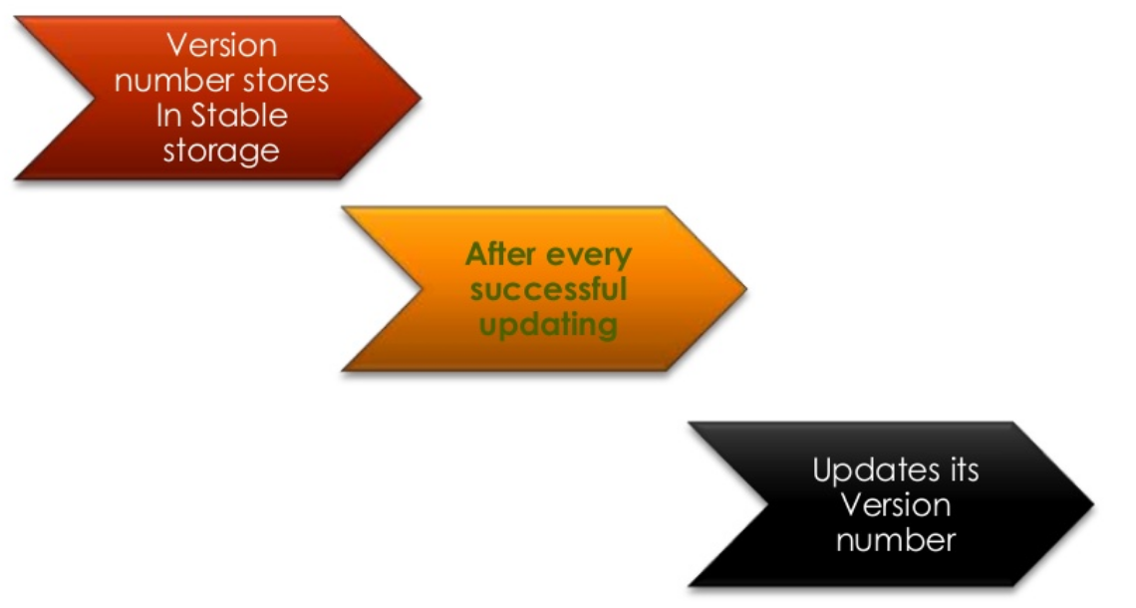

**Basic idea of Static Voting Protocol**

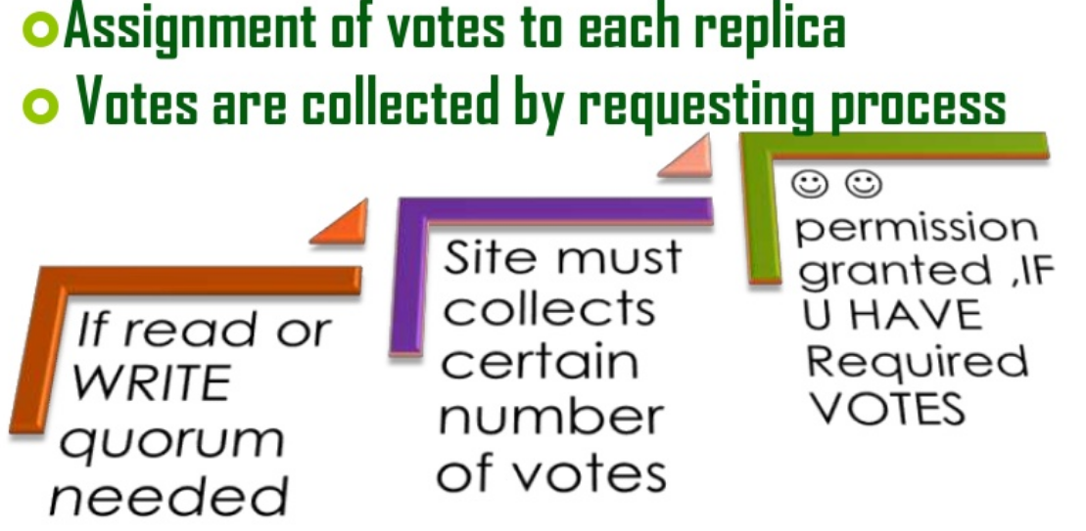

**Voting Protocol Algorithm**

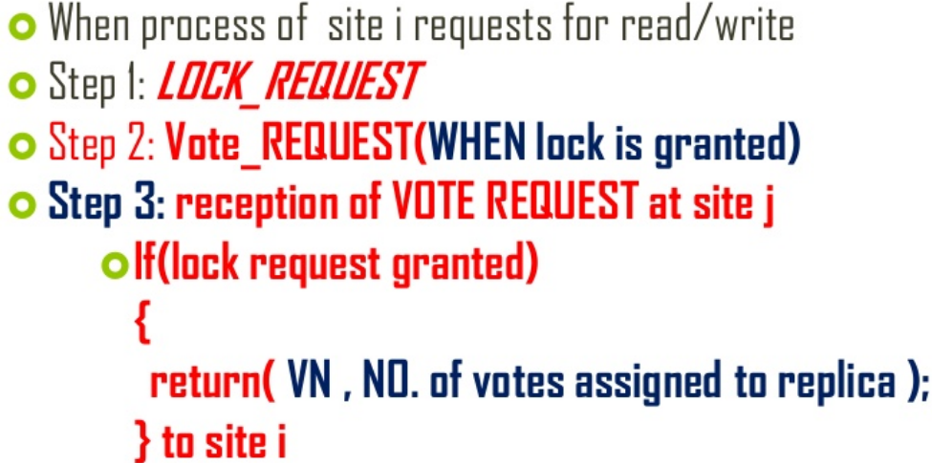

**Last steps of Static Voting Protocol (SVP)**

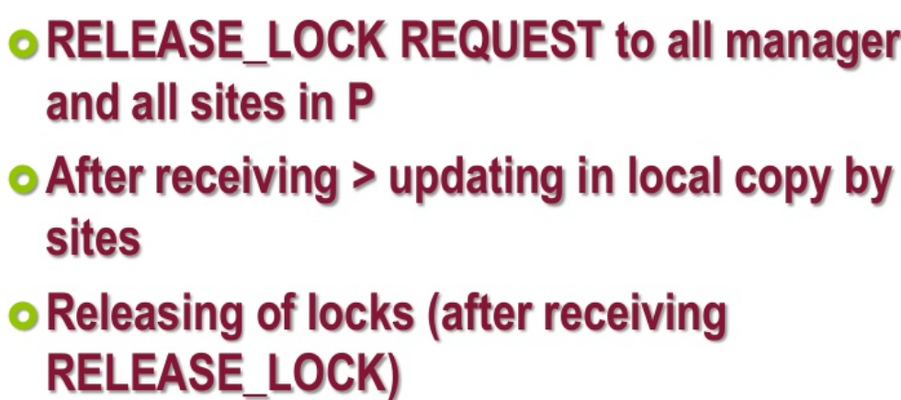

**Voting Assignment Policy**

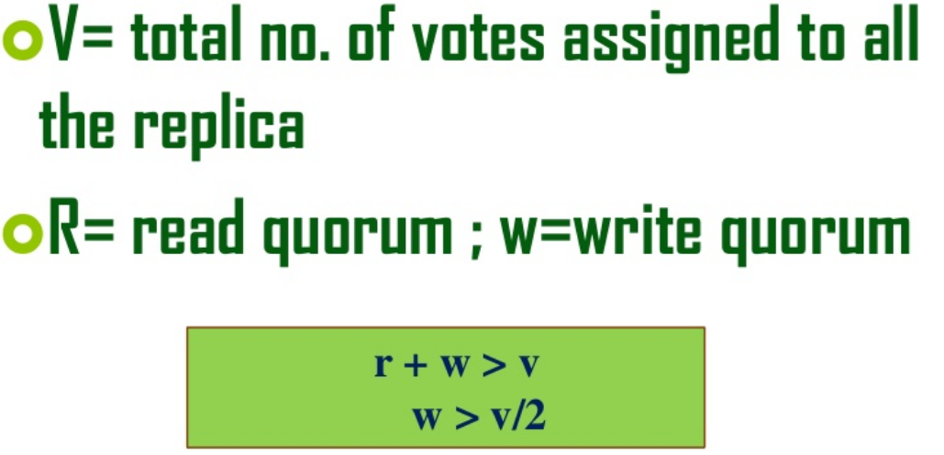

**Illustration of SVP (Static Voting Protocol)**

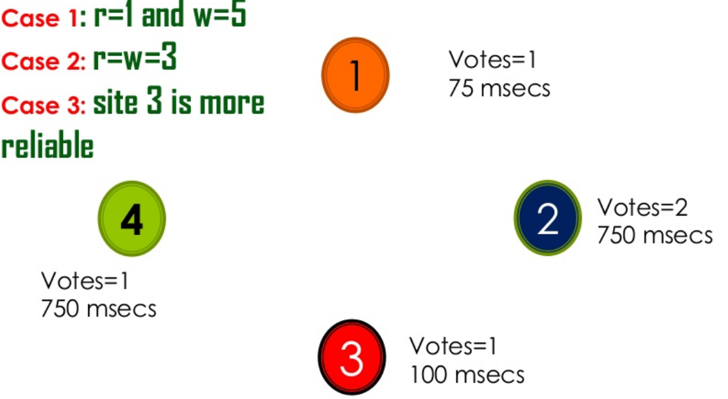

**Limitation of SVP (Static Voting Protocol)**

